OptiMIZATION TECHniques report - GROUP3

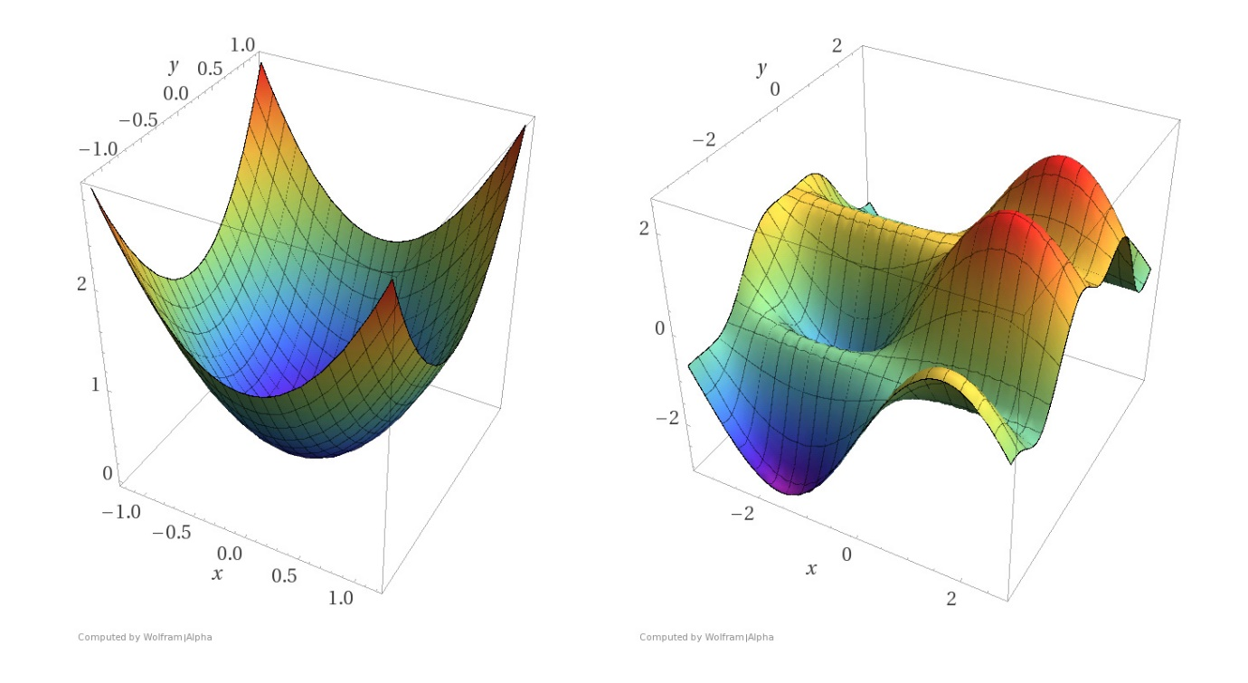

**Submitted By** –

CHAHINE Carl

SHAH Pooja

CAZILHAC Paul

BHURJI Prineet Kaur

BARKETALLAH Salma

TIRUMALE LAKSHMANA RAO Kiran

**Topic** – FACILITY Location

**Steps** –

$$N=\{(1,2,3,4,5)\}$$

$$E=\{\left(1,2\right),\left(2,1\right),(1,3),(3,1),(2,4),(3,4),(3,5),(4,5)\}$$

DEM_bound = 1

Minimize $f(x)=\sum_{(i,j)∈E}{ }d(i,j)×x(i,j)$

Subject to: $\left\{∑x(i,j)-∑x(j,i)=b(i)\right.∣i∈N \& j∈N(i)\}$ where N = neighbourhood

S $\text{ubject to: }\left.\left\{∑x(i,j)⩽∑a(i,j\right)∣i∈N \&j∈N\left(i\right)\right\}$

$$\text{Subject to: }\left\{x\left(1,2\right)⩽B_{1}×D_{em_bound}∣B_{1}∈\{1,0\}\right\}$$

$$\text{Subject to: }\left\{x\left(2,1\right)⩽B_{1}×D_{em_bound}∣B_{1}∈\{1,0\}\right\}$$

$$\begin{aligned}& \\ \text{ Subject to: }\left\{x\left(1,3\right)⩽B_{2}×D_{em_bound}∣B_{2}∈\{1,0\}\right\}\end{aligned}$$

$$\begin{aligned}&\text{ Subject to: }\left\{x(3,1)⩽B_{2}×D_{em_bound}∣B_{2}∈\{0,1\}\right\}\end{aligned}$$

$$\text{Subject to:} \left\{B_{1}+B_{2}= 1 ∣B_{1}∈\left\{0,1\right\} \& B_{2}∈\left\{0,1\right\}\right\}$$